Filling out the Application as a PDF

To fill out the application and submit it online, you will need to have Adobe Acrobat Reader. This is a free program that you can download here if you do not already have it on your computer. Once you have downloaded Adobe, you can download and open the rental application to fill it out.

Above the application, in Adobe, click on the “Tools” icon.

This should give you a list of tools to choose from, click on “Fill and Sign”.
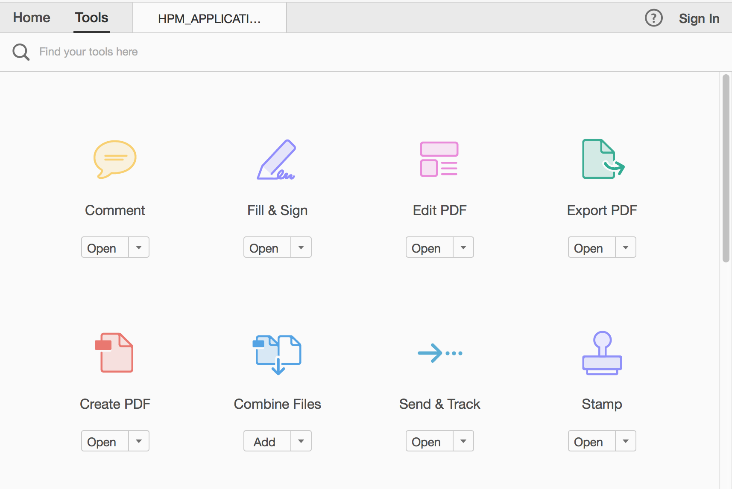

Once opened, there should be a list of tools at the top of the document.
Click “Add Text.”
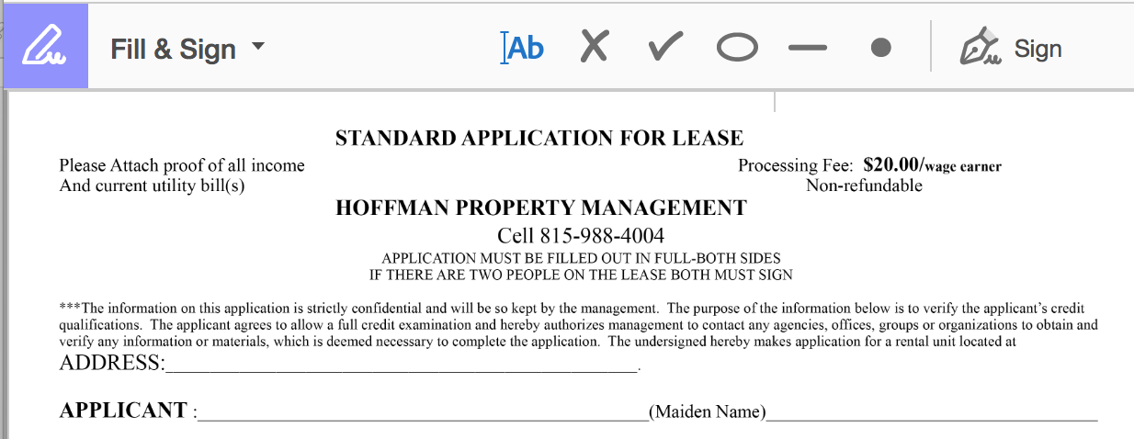

This will allow you to create a text box by simply clicking on the application.
- To move the text box, just click and drag.
- To make the text bigger or smaller, click on the large and small “A.”
- To delete an unwanted text box, click the trash can.
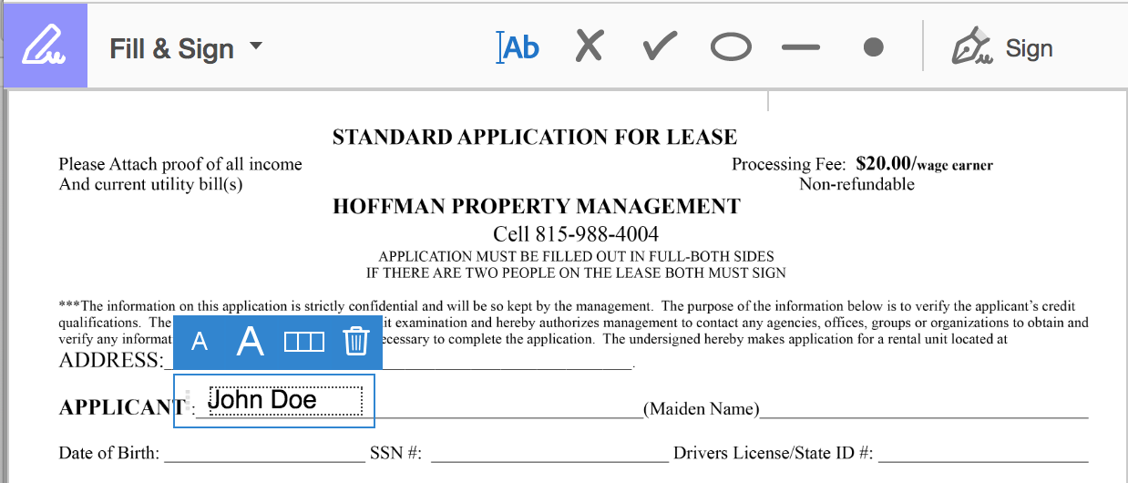

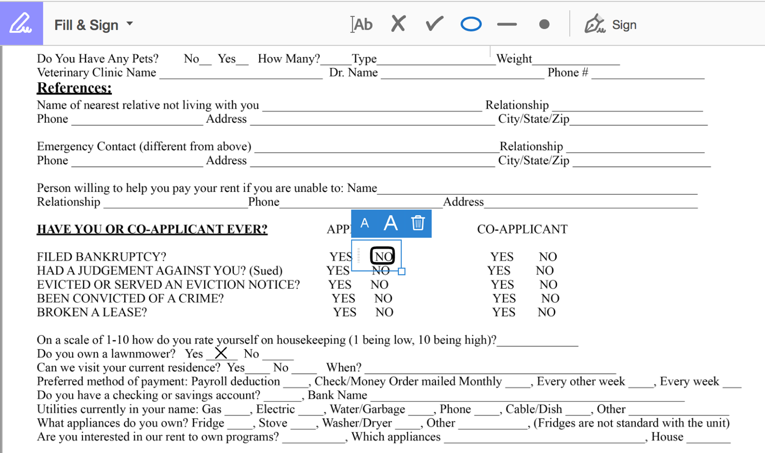
You can also add x’s check marks, and circles. Just click on the feature you would like to add, click on the document where you would like to add it, and use the tools the same way as before to move it/make it larger or smaller as needed.

Continue making text boxes, x’s, check marks, and circles until you have filled out all required information. At the bottom of the second page of the application, you will need to sign it electronically. Go back to the toolbar at the top of the application and click “Sign.”
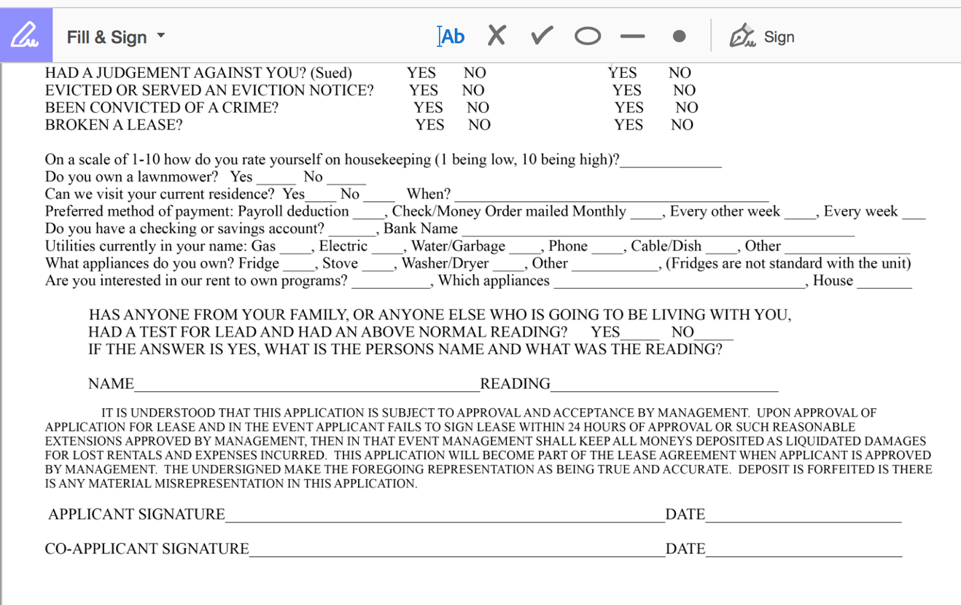

When you click “Sign” you should be given the option to “Add Signature” and “Add Initials.” Click on the plus sign next to “Add Signature.”
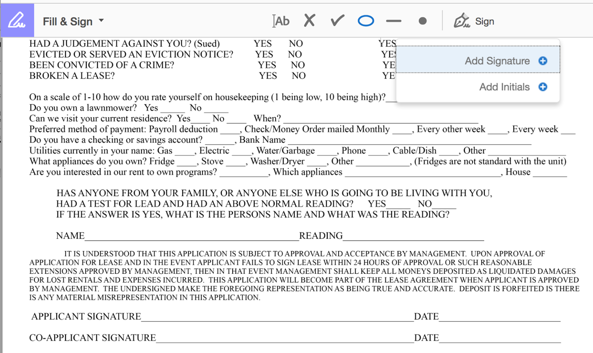

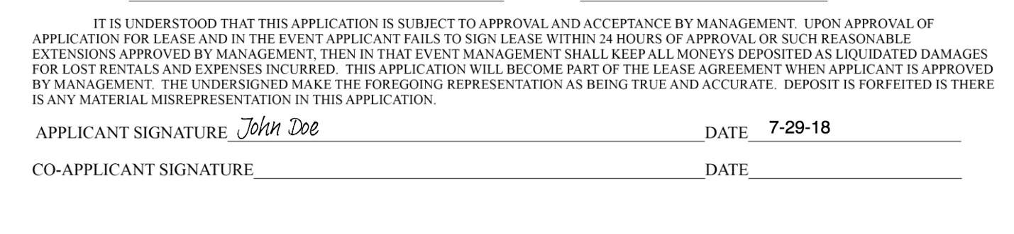

A box should appear that will allow you to type your name as a signature. When you are done, click “Apply” and move your signature to the correct line of the application. If you need to add a Co-Applicant signature, simply repeat this step.
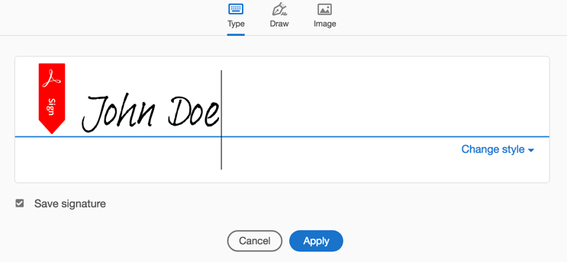

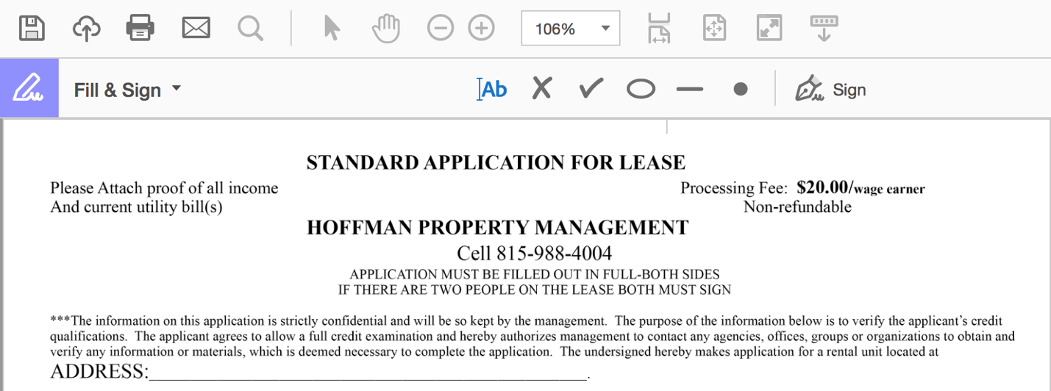
When your application has been completely filled out, click the “Save” icon at the top of the screen and all of your changes should stay in the document. If you wish to change the name of your document, on your computer’s tool bar, click “File” and “Save As.”

You have completed filling out our application for lease online. Please email us the completed document and pictures of your proof of income and current utility bill(s). Once we have received the completed application, proof of income, utility bills, and $20 application fee for all adults listed on the application we can begin our reviewing process and we will typically get back to you within 24-48 hours.

Thank you for your interest in renting from Hoffman Property Management and Titan Rentals and for taking the time to fill out our application completely. If you have any questions, please contact us via email at timsrenals@gmail.com or phone at 815-988-4004.

